

NATIVE MOBILE PROGRAMMING (CSM 3505)

Report Lab 6

**Lecturer : Dr. Rabiei Mamat**

**Demonstrator : Dr. Rabiei Mamat**

Programme : Computer Science (Software Engineering) K1

Name : SIEW KING SAM

Matric : S62270

Date : 26/12/2022

Badges

Result of the quiz

Pathway 1

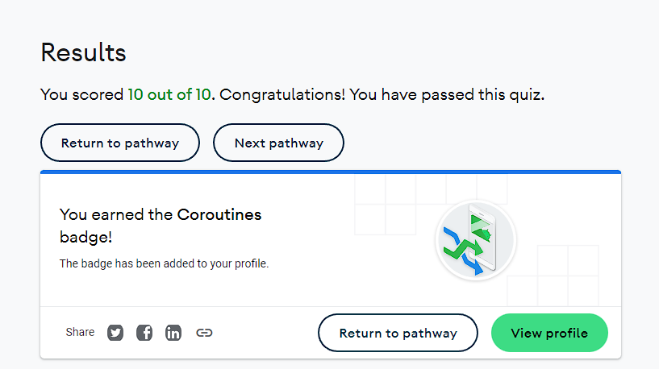

Pathway 2

GitHub Links

Link to the Lab folder

<https://github.com/S62270/S62270_Lab5>

Pathway 1

Activity 2

<https://github.com/S62270/S62270_Lab5/tree/main/Activity%202%20pathway%201>

Activity 3

<https://github.com/S62270/S62270_Lab5/tree/main/Activity%203%20pathway1>

Activity 4

<https://github.com/S62270/S62270_Lab5/tree/main/Activity%204%20pathway%201>

Pathway 2

Activity 2

<https://github.com/S62270/S62270_Lab5/tree/main/pathway%202%20activity%202>

Activity 3

<https://github.com/S62270/S62270_Lab5/tree/main/pathway%202%20activity%203>

Pathway 3

Activity 2

<https://github.com/S62270/S62270_Lab5/tree/main/pathway%203%20activity%202>

Activity 3 <https://github.com/S62270/S62270_Lab5/tree/main/pathway%203%20activity%203>

Pathway 4

Activity 2

<https://github.com/S62270/S62270_Lab5/tree/main/pathway%204%20activity%202>

Activity 3

<https://github.com/S62270/S62270_Lab5/tree/main/pathway%204%20activity%203>

Activity 4

<https://github.com/S62270/S62270_Lab5/tree/main/pathway%204%20activity%204>

Pathway 5

Activity 2

<https://github.com/S62270/S62270_Lab5/tree/main/pathway%205%20activity%202>

Activity 4

<https://github.com/S62270/S62270_Lab5/tree/main/pathway%205%20activity%204>